**Create a Kubernetes cluster using minikubes**

To create a kubermetes cluster first we will have to install Minikube and Kubectl and checking their installation using following commands:

$ minikube version

$ kubectl version

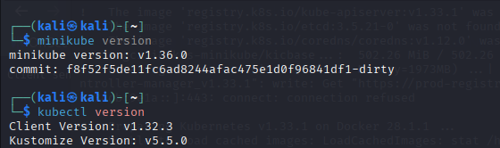

Now I’ll start minikube and specify drive as docker

$ minikube start --drive=docker

By using this it will use Docker as VM driver.

This will:

* Download a Minikube ISO
* Create and configure a virtual machine or container
* Deploy a single-node Kubernetes cluster

Now we verify clusters status

$ minikube status

To interact with cluster I’ll run

$ kubectl get nodes

It will information about running node

Enable Dashboard

$ minikube dashboard

Stop Minikube

$ minikube stop

Delete Minikube

$ minikube Delete